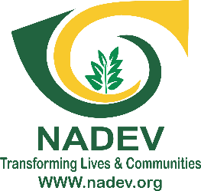

NKONG HILL TOP ASSOCIATION FOR DEVELOPMENT (NADEV)
SOUTH WEST REGION – CAMEROON
Reference | Call to Tender #_0007__/NADEV/GIZ/PROSCIG/2026
Date | 21st August 2026
Project | Project for Strengthening CSOs and Gender Inclusiveness (PROSCIG) – GIZ/BMZ
Service Location | Kumba City, Meme Division, South West Region, Cameroon
CALL TO TENDER – PROVISION OF CATERING SERVICES
Nkong Hill Top Association for Development (NADEV), under the Project for Strengthening CSOs and Gender Inclusiveness (PROSCIG), supported by the German Federal Ministry for Economic Cooperation and Development (BMZ) through GIZ, invites qualified catering service providers to submit their best offers for the provision of catering services for project activities implemented in Kumba City.

1. Background and Purpose of the Tender
The RISE Project (Resilience & Inclusion through Socio-Economic Empowerment for GBV Survivors in Kumba City) seeks to strengthen the socio-economic resilience of 30 GBV survivors through psychological support, vocational and professional training, cooperative/Common Initiative Group strengthening and implementation of income-generating activities. The project includes stakeholder engagements, working sessions, trainings, counselling/support sessions, coaching activities and other project meetings requiring appropriate catering arrangements.
The purpose of this tender is to establish a qualified catering service provider capable of supplying safe, hygienically prepared, nutritious and timely meals and refreshments for NADEV project activities in Kumba.

2. Objective of the Catering Service
To provide quality catering services for participants, facilitators, project staff and invited stakeholders during approved project activities, in accordance with agreed menus, quantities, prices, timing, hygiene and safeguarding standards.

3. Scope of Services
- Preparation and provision of meals, snacks and refreshments for project meetings, workshops and training sessions.
- Delivery and/or on-site serving of catering services at venues designated by NADEV.
- Provision of drinking water and appropriate beverages/refreshments as specified in the activity order.
- Provision of appropriate serving materials, where requested, including plates, cups, cutlery, napkins and related items.
- Timely setup, serving and removal/clean-up of catering materials where applicable.
- Adjustment of quantities according to the confirmed number of participants for each activity.
- Compliance with food safety, hygiene, quality and applicable public health requirements.

4. Indicative Catering Schedule / Price List
Bidders should provide unit prices for the services below. Actual quantities will be confirmed through individual service orders based on the approved activity and participant numbers.
No. | Service/Item | Unit | Unit Price (FCFA) | Delivery/Service Cost | Tax/Other Cost | Total/Unit (FCFA)
1 | Breakfast / light breakfast
2 | Lunch meal – standard menu
3 | Lunch meal – enhanced/special menu
4 | Morning tea/coffee break with snack
5 | Bottled/sachet drinking water
6 | Soft drink / non-alcoholic beverage
7 | Fruit/healthy snack
8 | Packed meal / takeaway meal
9 | Buffet service
Note: Menus should be proposed in a manner suitable for diverse participants. The caterer should indicate portion sizes and the main components of each proposed meal/menu.

5. Minimum Service and Quality Requirements
- Meals must be freshly prepared and served at the agreed time.
- Food must be prepared, stored, transported and served under hygienic conditions.
- The caterer must use clean utensils, serving materials and appropriate food containers.
- The caterer must maintain adequate food safety practices and prevent contamination.
- Meals should be nutritious and provide reasonable variety.
- The caterer should be able to accommodate reasonable dietary restrictions communicated in advance.
- No alcoholic beverages shall be included in catering supplied under this tender.
- The service provider must have sufficient personnel and logistical capacity to serve the confirmed number of participants.
- NADEV reserves the right to inspect catering arrangements and reject services that do not meet agreed requirements.

6. Supplier Eligibility and Submission Requirements
Interested catering service providers should submit:
- Valid Business Registration Certificate (RCCM or equivalent).
- Valid Taxpayer Identification/Taxpayer’s Card or equivalent tax document.
- Bank Account Attestation in the name of the business/company.
- Company/business profile and contact details.
- Evidence of capacity to provide catering services for meetings, workshops or training events.
- Evidence of previous catering contracts or similar assignments, where available.
- Proposed menus and corresponding unit prices.
- Proposed service/delivery arrangements and lead time.
- Evidence of compliance with applicable food hygiene/public health requirements, where applicable.

7. Financial Offer Format
All quotations should be submitted in FCFA and should clearly indicate applicable taxes and other charges.
No. | Description/Menu | Unit | Estimated Qty | Unit Price (FCFA) | Other/Tax Costs | Total (FCFA)
1
2
3
4
5
6
7
8
9
10
Grand Total (FCFA): ______________________________
Amount in words: ________________________________________________________________
Quotation validity: __________________ days.

8. Evaluation Criteria
Criterion | Assessment | Indicative Weight
Administrative compliance | Completeness and validity of required documents | Pass/Fail
Quality and suitability | Menu quality, hygiene, portioning, presentation and service capacity | 35%
Price and value for money | Competitiveness of proposed rates and overall cost | 40%
Experience and capacity | Previous similar assignments and ability to serve required numbers | 15%
Timeliness/logistics | Ability to deliver and serve at agreed times and locations | 10%
NADEV may request clarifications, samples/menu demonstrations or additional evidence of capacity before award. The lowest-priced offer will not automatically be selected where quality, hygiene, capacity or value-for-money requirements are not met.

9. Ordering and Service Delivery
- Catering services shall be requested through an approved purchase order, service order or other written authorization from NADEV.
- Each order will specify the activity, date, venue, number of participants, menu, quantities and agreed service requirements.
- The caterer must confirm acceptance of the order and report any constraint immediately.
- NADEV may modify participant numbers within a reasonable period before the activity, subject to agreed terms.
- Invoices must correspond to services actually provided and accepted by NADEV.

10. Payment Terms
Payments shall be made in the name of the contracted catering service provider through cheque or bank transfer, subject to satisfactory delivery of services, confirmation/acceptance by NADEV and submission of the required invoice and supporting documents. Specific payment terms will be stated in the purchase order or contract.

11. Safeguarding, PSEA and Professional Conduct
The selected catering service provider must comply with NADEV’s safeguarding, Child Protection, Prevention of Sexual Exploitation and Abuse (PSEA), anti-fraud and anti-corruption requirements and applicable donor compliance requirements.
- Catering staff must maintain respectful and professional conduct with beneficiaries, staff and stakeholders.
- No exploitation, harassment, discrimination or abuse of participants will be tolerated.
- The caterer and its personnel may be subject to due diligence and anti-terrorism screening.
- Catering personnel must not photograph, record or publicly identify beneficiaries without authorization from NADEV.
- Any safeguarding concern observed during an activity must be reported through the channels communicated by NADEV.

12. Security and Conflict-Sensitive Delivery
Considering the security context in the North-West and South-West regions, the service provider must follow NADEV’s security instructions and avoid exposing project participants, staff or catering personnel to unnecessary risks. Activity times, venues and delivery arrangements may be changed when required by the security situation.

13. Submission of Offers
All offers should be addressed to:
The CEO and Administrative Officer
Nkong Hill Top Association for Development (NADEV)
Buea – South West Region, Cameroon
Submission method: Sealed envelope at the NADEV Office, Buea (Bwitingi Road, HIBMAT Campus B), or by email to info@nadev-cameroon.org.
Tender deadline: 11th September at 4PM.
The tender reference should be clearly indicated on the envelope/email subject. Late submissions may be rejected.

14. Reservation of Rights
- NADEV reserves the right to accept or reject any offer in whole or in part without assigning reasons.
- NADEV may cancel or amend the tender process where necessary and communicate material changes to bidders.
- NADEV may negotiate with the preferred bidder where permitted by its procurement procedures.
- Award is subject to availability of funds and donor/project procurement requirements.
- No bidder shall be entitled to compensation for costs incurred in preparing or submitting an offer.

15. Contact Information
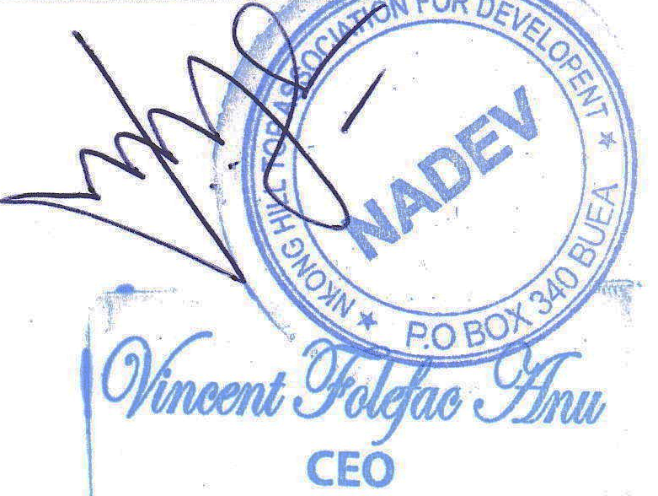
Nkong Hill Top Association for Development (NADEV)
South West Region – Cameroon
Tel: +237 677 64 81 13 / 652 58 31 14
Email: info@nadev.org
Website: www.nadev.org

